Interstellar Life 4 - Extraterrestrial Engineering - Reactors/Plasma Engines (Taygeta - Pleiades)
ORIGINALLY IN ENGLISH - 2021
Gosia: What do they look like, Zero Point reactors?
Swaruu X (Athena): A Zero Point reactor may look different depending on the species, culture, size and model of the craft, but here I will concentrate on two kinds that are mostly used in so called 'modern times' by the Taygetan culture that mostly only vary in size. One, the larger ones used on big and heavy starships, and the smaller variant used for small agile craft such as fighter types.
From inside a ship, be in large or small, once you are in the reactor control room, in the engineering levels of the craft, all you can see is a flat metal color smooth wall with large rectangular panels with no handles. On some ships, all you can see are two walls at 90° angles of the same smooth metal steel color with removable panels. Those panels can all be removed until the point where the entire wall is gone.
In a Suzy class II fighter class ship, the control room from where you can see this wall is a white square small room with no right angles at its corners, no larger than 8 square meters. The walls are flat, but all the corners are rounded out and they are all clean white with a white ceiling and light coming from a large ring on the roof that almost touches the walls in its circumference.
The main entrance is on the wall opposite to the reactor wall, and is a large rectangular sliding door, rounded edges, and the top half of these doors are transparent. The floor is dark gray and in the center there are two white rectangular panels with the control surface slanted at a slight angle. When in off position, the control surface is black glass. When on, it manifests, or produces, the controls, buttons and leavers, as 3D holograms over that surface as needed. The control display screens are only of the holographic kind appearing in front of the user, presenting all the data as needed. This 3D hologram screen can be modified in size and the objects there can be manipulated by hand or by thought using brain to AI interface at will.
The reactor itself, as seen when removing the access panels described above, or as seen before it is installed on a ship, as for example as when it is standing alone in a warehouse, is a large metal sphere. Size varies according to the ship it´s meant for, and what is visible is a web of carefully ordered oval shaped tubing covering its entire surface and orderly coming out from each panel or subsection of the surface of the sphere and moving downwards towards the floor, each one ending with connectors and adapters to install it on the ship's reactor room. Among this tubing, there is another less visible web of room temperature superconductor cables of small caliber.
Both, the sphere itself and its oval tubing, are steel color, the cables are black with bronze color connectors. The tubing is placed around the sphere in such an ordered manner that it would remind you of solid state circuitry. When I say oval shaped tubing, it means that if you cut one of these, the cross section would be a flat oval in shape and not round.
Very close image. But in steel color, not green.
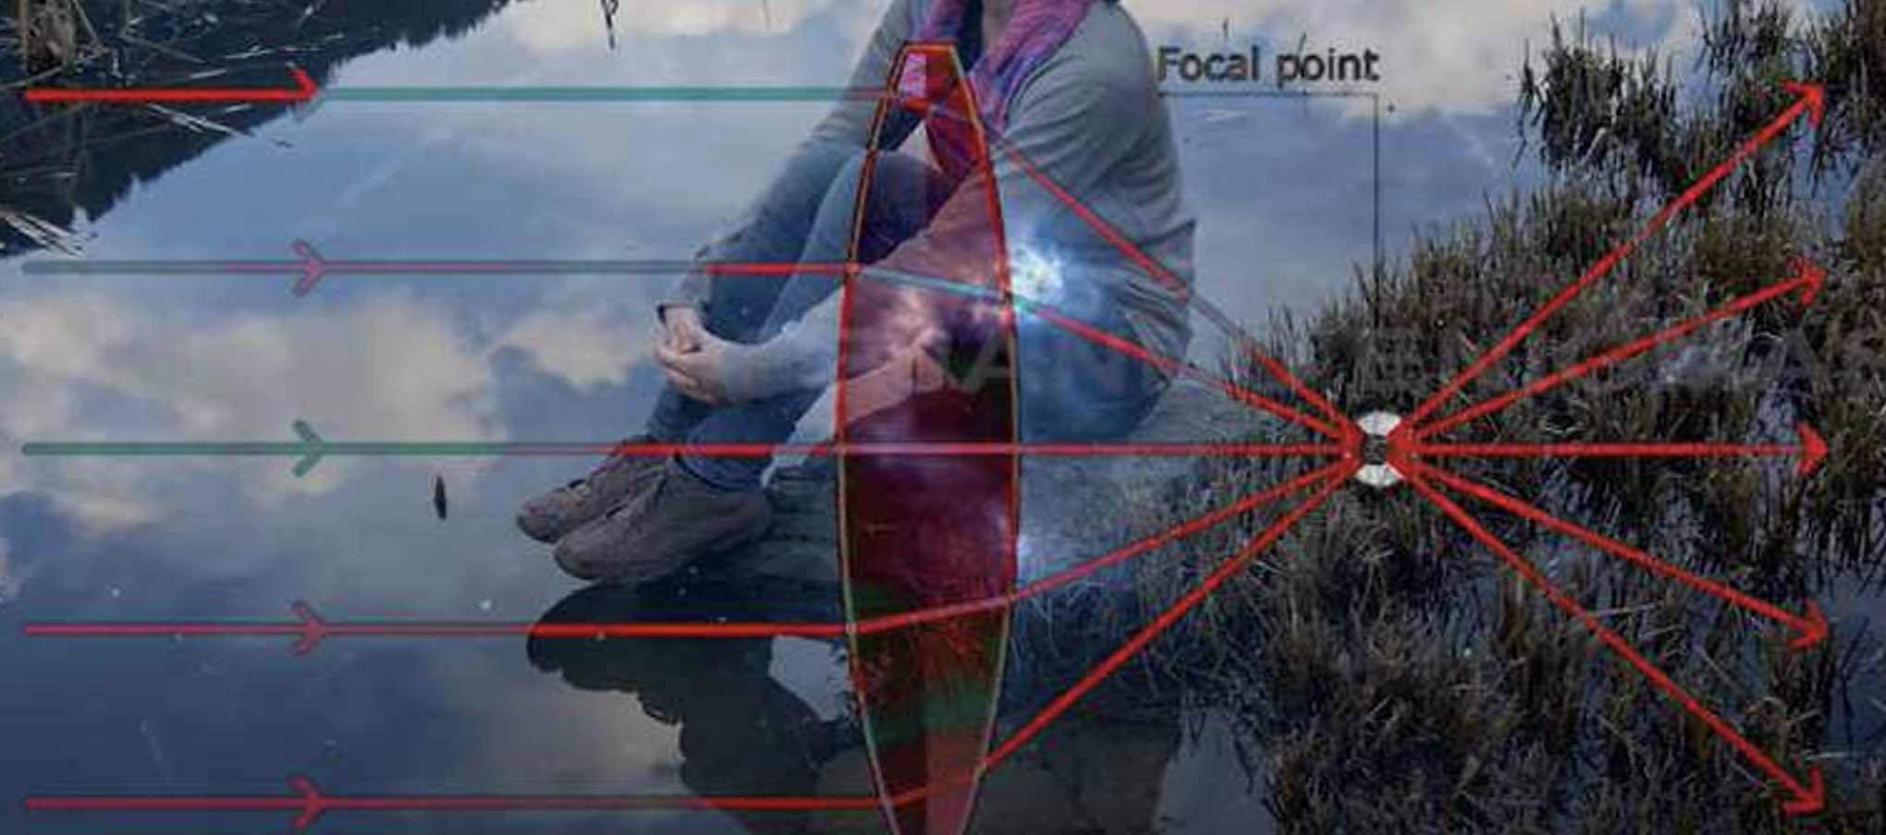
Although in this section I will only be describing how a Zero Point reactor looks like and not how it works, as that has been described in detail before, I will mention a few things here.
The web of oval tubing enveloping the entire reactor sphere is not for one purpose only. It is conduit tubing, that is multiple functions, and sub tubing, wires and pathways are contained inside them for many purposes. Some provide protection for super conducting cables that feed the artificial gravity manipulation electromagnetic frequency generators that control the reactor's core. Others are the cables that conduct the electricity generated by the reactor's core to the 'electric current collectors', for lack of a better word. Others take electricity from the thermo-electric cells on the inner surface of the sphere, also to the 'collectors' equivalent to perhaps capacitors.
Among the thermo-electric cells inside the inner reactor sphere wall, there is also a web or array of tubing set as a spherical heat radiator that covers the entire inner surface. This radiator is filled with coolant fluid and is to cool the reactor, to keep it at the desired inner temperature. This hot fluid is then cooled off using hydro-thermic electric units that transform heat into more electricity.
Over this special radiator like cooling system tubing the gravity generators, electromagnetic frequency modulators are installed and in between them there are thermo-electric panels as well.
The core of the reactor, as described before, is a complex 12 stage toroid sphere made of hundreds of thousands of minute sand grain size Merkabah shaped synthetic quartz objects floating in a computer controlled gravitational field that conducts them to move in a 12-toroidal trajectory. This is one toroid inside another, inside another, each forming the other, for 12 levels. But to the eye it basically looks like a glowing semi-transparent sphere moving on itself floating in the center of the reactor sphere.
The best image I have to explain this is the following one. And we have had it for years as a note: (this is GIF but in a text it is static)
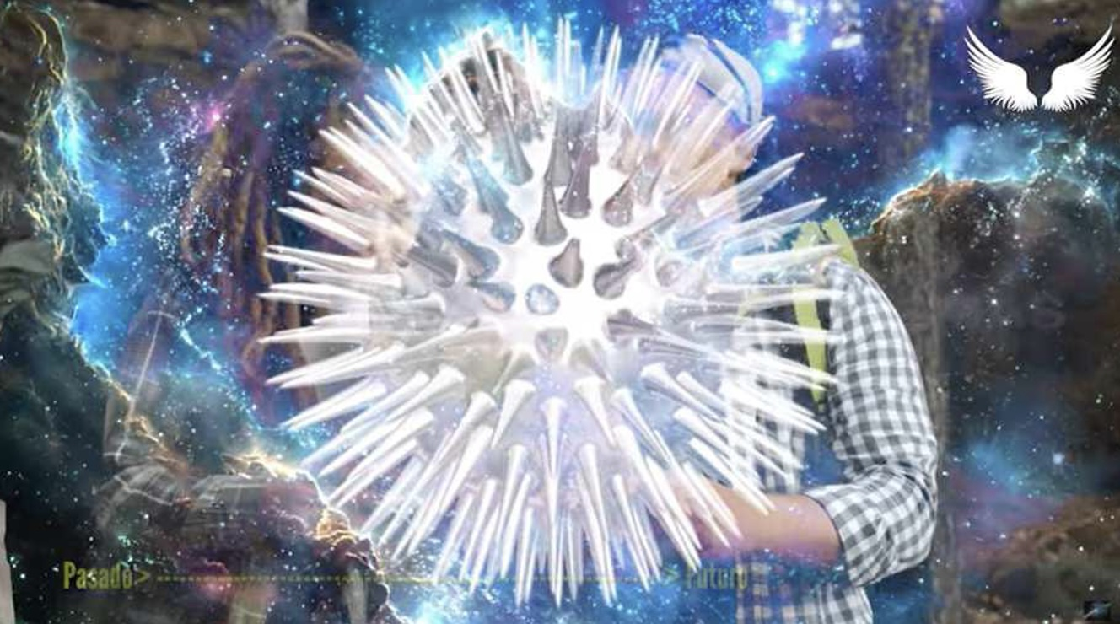
This is the closest image we can get to describe how the inside of a Zero Point reactor looks like. Complete with the coolant radiator, cooling units and the square shaped thermo electric collectors and the gravity generators in the background, and the reactor toroidal core sphere in the foreground.
This is GIF too:

The power output from any Zero Point reactor based on crystal Merkabah toroids, therefore giving way to the name Crystal Core Zero Point reactor, is controlled by the electromagnetic gravity generators that are, in turn, controlled by the ship's AI. And it is achieved by varying the distance between and the density of the artificial quartz Merkabah’s as well as the speed of rotation of the entire toroid, or also varying the speed and relative speed of rotation between each one of the 12 levels that make up the toroid.
Basically, the main principle is that when the toroidal sphere is larger, it has less density, therefore less spark-gap action between the quartz Merkabah’s, therefore reducing the potential output. And when the toroidal sphere is smaller and moving faster in inner and outer rotation, it has more density, therefore generating more spark-gap action (for lack of better words), and with it more electricity and more heat and luminosity.
The Merkabah shaped synthetic quartz crystals are made with precise mathematical precision and precise size and proportions. They are made of chemically pure crystal. That's why they must be artificially created, and also have precisely engineered piezoelectric properties. The mathematical base the quartz Merkabah´s follow is based on precise 12 base math equations, as described in previous work.
Looks like a small Zero Point reactor. Image: small fusion reactor.

As said above, the size of a Zero Point reactor depends on what it will be used for. In a large cruiser, like Toleka class, they are near to 10 meters in diameter and a ship of that mass has four of them to feed its large engines and systems. In a smaller craft, like a Suzy class II, they are much smaller, being that the reactor sphere itself is only about 3 to 3.5 meters in diameter (not counting tubing and additional machinery).
But I know much larger Crystal Core Zero Point reactors have been built. And on the other side of the spectrum, there are Zero Point reactors that work with the same principle that can fit inside the palm of your hand. They are used to power small drones, long range electronic equipment for space travel, and to power weapons such as advanced ACR plasma rifles and smaller ACPs, both capable of a high rate of fire or recuperation time and with no need to reload as they never run out of ammunition, among many other uses.
(As a side note, in places like Temmer or Erra, inside a planetary wireless power grid, such small reactors are not needed to power everyday devices as they all take their energy from wireless electricity transmission technology, similar to Tesla's on Earth, before been hidden from the public by Thomas Edison, as it would be impossible to place a meter and therefore to bill their customers).
About the shape and color of inner merkaba quartz crystals that make up the core of the reactor, they are about the size of a grain of fine sand or of salt.

Only difference being that there, in the image, are three sided Merkabah objects, and the ones in Zero Point reactors are four sided Merkabah objects, as in the shape of two pyramids placed one inside the other, one upside down opposed to the first.
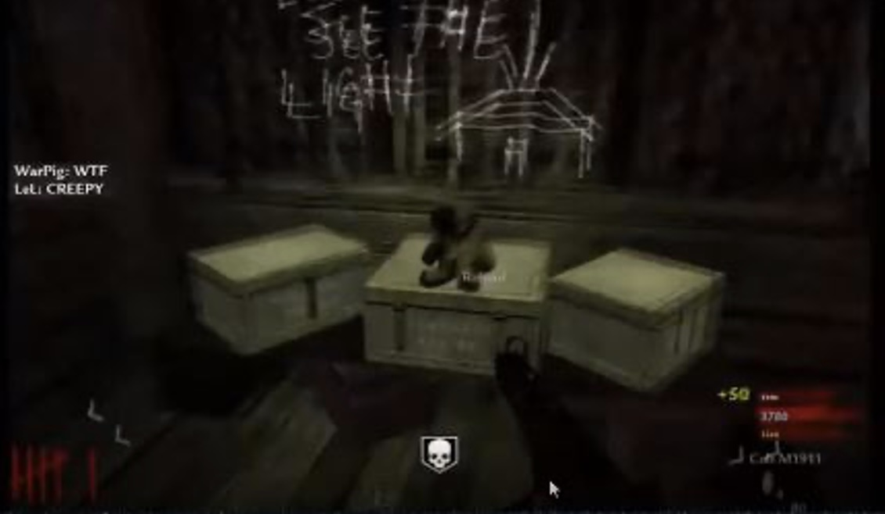
Plasma turbine engines
There are several variants of plasma drive turbine engines. I do use the name "turbine" because it does spin inside, so it is a turbine. Contrary to a jet engine, it has no compressor, compressor stages, burners or afterburners. It does not require any kind of fuel or propellant. It works by spinning its components in opposite directions while being fed trillions of electron volts, and this creates a very large electromagnetic plasma field.
The size of the engine varies depending on the ship but all work with the same principle. It is a cylinder or large pipe, hollow inside, with a cone at its rear. The walls of the cylinder is the turbine itself, and it is made of several layers cylinders one inside the other. The amount of these cylinders depends on the model of the ship, but most large ones and some fighter class have 12 layers, each one rotating in the opposite direction.
Although on the exterior an electromagnetic plasma engine can look very much alike a jet engine, inside it is very different, but the overall exterior look is very similar.

In principle, each layer rotates in the opposite direction to the former one, clockwise, the other counterclockwise. Each one is fed a different high voltage electric polarity, and they all rotate over the same center or geometric axle. This creates a strong electromagnetic field, as said before. This field holds a frequency, and this frequency is controlled by the ship's AI computer. Controlling this frequency is achieved by varying the speed of rotation, voltage and the relationship between the rotation patterns between the layers of the counter-rotating turbine.
In older ships, the turbines were made of a set of cylinders one inside the other, like Matryoshka Russian dolls. And the power to each level, or to each individual rotating drum, is achieved using a power distributor device at the front end of the turbine, opposite from the exhaust nuzzle.
In more recent ships, this is achieved by changing the molecular structure of each layer in waves. One clockwise, the other counterclockwise.
Each cylinder level that makes up the turbine will have its molecular structure change causing a ripple that goes around each cylinder.
It is critical to understand that the material used in this kind of state of the art turbines is polymorphic crystalline metal super alloy. This means that its very molecular structure changes according to what the computer dictates to them. So, if you have an apparently solid turbine drum, and you change the molecular crystalline structure that makes it up in a progressive manner, as in a wave, you create the illusion of spinning within its molecular matrix.
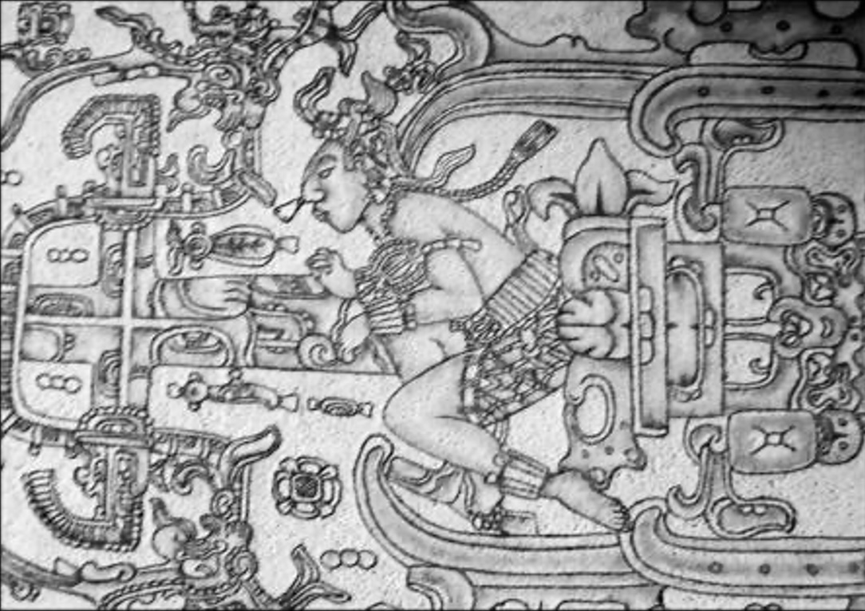
Polymorphic metal
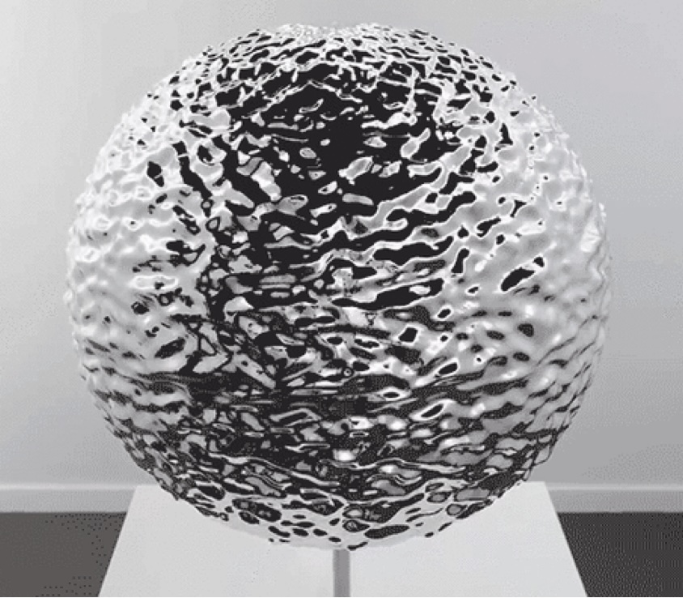
As seen here, the little spheres are the molecular structure of the metal and it is the structure, the molecules themselves that change under IA control to create the illusion of spinning.
A crystalline molecular structure in a substance or material is when the molecules are set with a precise geometrical shape and order. This is the basic principle behind transparent materials. As their structure is so in order, it lets light pass through with little resistance, therefore becoming translucid.
Same effect applies to super conductor materials where electricity can flow through the molecules of the material without encountering any resistance.
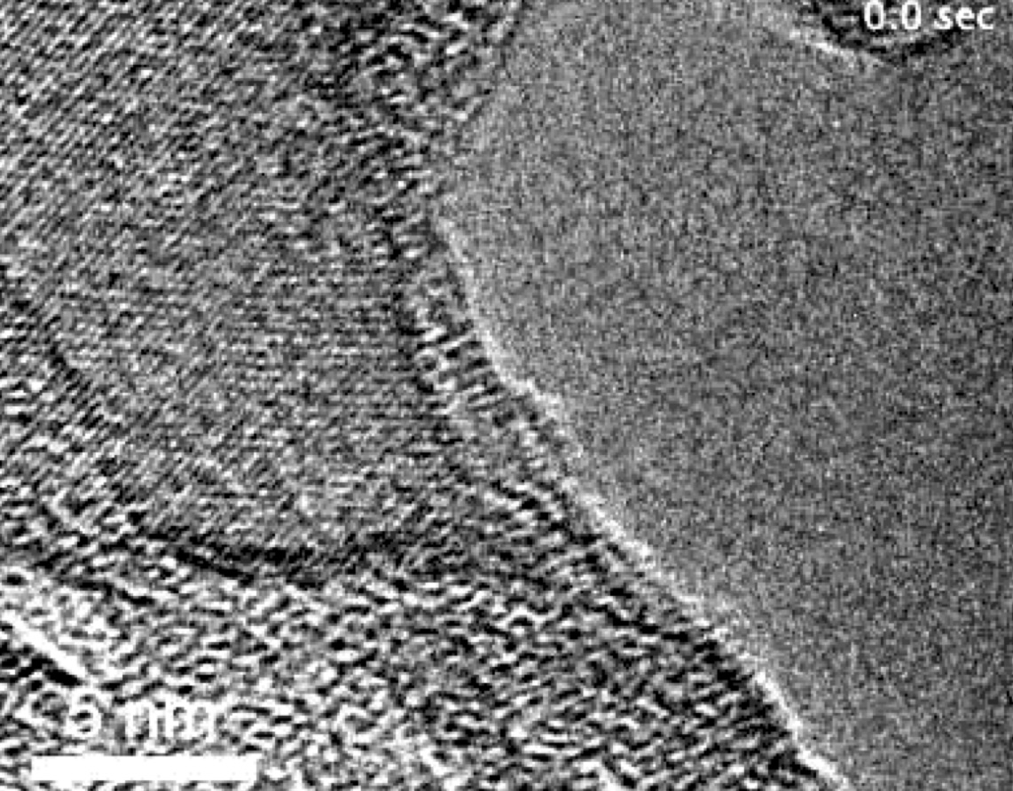
When electricity passes through a non-super conductor material, such as copper wire, for example, it flows in a chaotic manner, each electron in the electric current banging and fighting its way through the metal's chaotic structure.
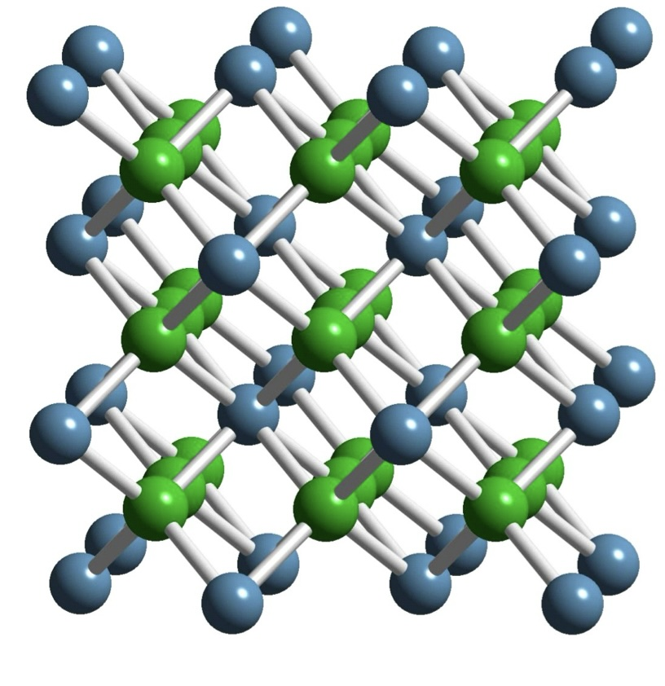
Perfect crystalline metallic molecular matrix, similar to the one found in super conductors:
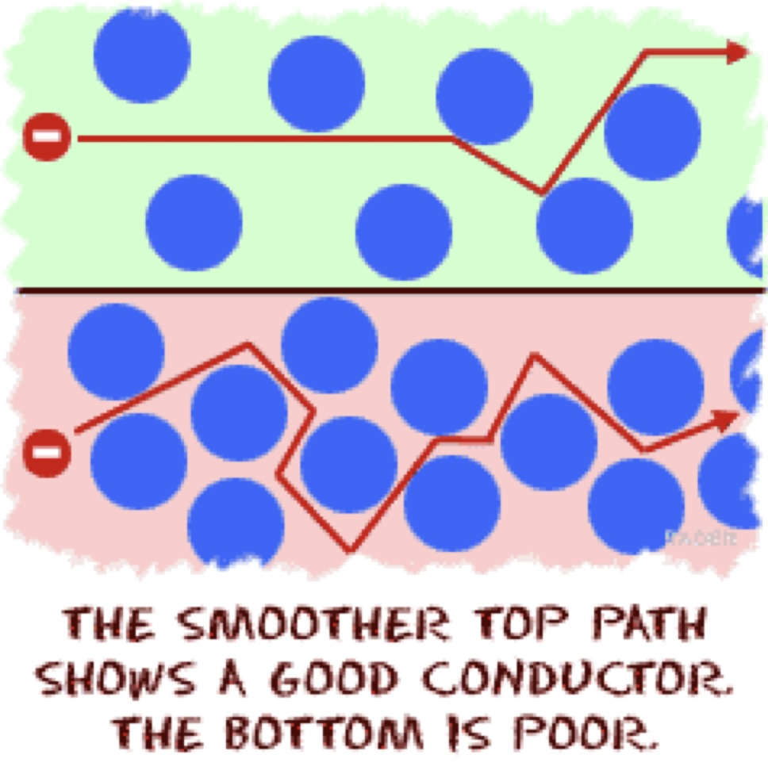
So, going back to state of the art electromagnetic plasma turbines used for starships. Each drum layer will have its crystalline structure change due to its polymorphic metal properties as controlled by the ship's AI using gravity and frequency management to target specific areas in the turbine's structure to change. Polymorphic metal's molecules react to frequency and to gravity forcing them to change their relationship to one another (more on that). This change can be seen in a molecular lever as a ripple moving its way around the drum.
On each level of the drums that are one inside another, the 'wave' will be moving in one or another direction, causing a spinning effect even if there are no moving parts. This is the most important difference between old starship technology and state of the art as used on a Suzy II class. No moving parts, and all done with polymorphic metal properties. Plasma turbines in older ships did rotate as a complete turbine, and in counter rotation according to the levels.
The fact that there are no moving parts, but still the molecular effect is that of a turbine, causes this type of engine to be far more reliable than the spinning type, and also permits its frequency output to be far more precise.
As the turbine spins molecularly, the AI changes the composition or 'shape' of the crystalline structure of the turbine, altered in density and in shape. With this, the high voltage electric current flowing through it in a super conductive manner encounters more or less resistance, and this causes its electromagnetic frequency to change as well, therefore changing its frequency relationship with other layers of the entire turbine engine. And the sum of all the interactions between the layers in the engine's interior turbines will result in the total or raw frequency output of the entire engine.
By changing the interior frequency relationships between its components, the plasma flow out of the engine nuzzle will have a specific frequency. This specific frequency is of a very high energy nature due to the amount of raw electric power that is fed into the engine in the order of several trillion electric volts or TEV (not giving away specific power readings).
As explained in other works, a starship, when navigating faster than light, does not really move, so it is not propulsion. A ship will alter its specific frequency to match the one of the destination, therefore "jumping" there. This means that space maps must be made using frequency only. This is reading the specific frequency of each 'place' in a grid in space and memorizing it in the AI computer.
So, in principle, when a ship must travel from place 'A' to point 'B', all it needs to do is to change its entire frequency, the frequency of vibration, as in density and dimensions, of the entire ship, so it will no longer be 'compatible' with location place 'A' and will be to the desired destination, place or location 'B'.
This illustrates why the management of precise frequency outputs of the engines is so important. Also because the engine must emulate or accommodate precise micro frequency adjustments to compensate for other unknown factors that may disrupt the entire frequency output causing a probable deviation from its destination, or simply to micro adjust where and when a ship will arrive to its destination, or point 'B', in the example above. Because, as a location is a specific frequency within a map, so is time, and the precise moment a ship should arrive to set destination 'B'. All this controlled with the engines frequency output system management.
As places and locations are frequencies within a map or grid, all represented by numerical factors, so is time. The moment in time, past, present or future of a location, is also managed with the use of controlled frequencies that are already known to be representative of the desired location and point in time. Point in space-time.
Altering the entire ship's frequency of existence, or vibration, to match the one of its desired destination, is achieved using a full immersion toroid effect caused by the high energy electromagnetic field that its engine or engines produce. Being that the core of the engine is the core, or so called "engine" as well, of the entire toroid, where one polarity is at the rear as an electromagnetic plasma output, and the other polarity is found at the nose of the starship, being that the toroid is connected to the turbine and toroidal engines using the hull and structure of the craft itself, being helped mainly by massive superconductive cables that run from the special nose of the craft that acts as a receptor to the back of the engines where the electromagnetic energy is added to the new one the engine(s) are producing.
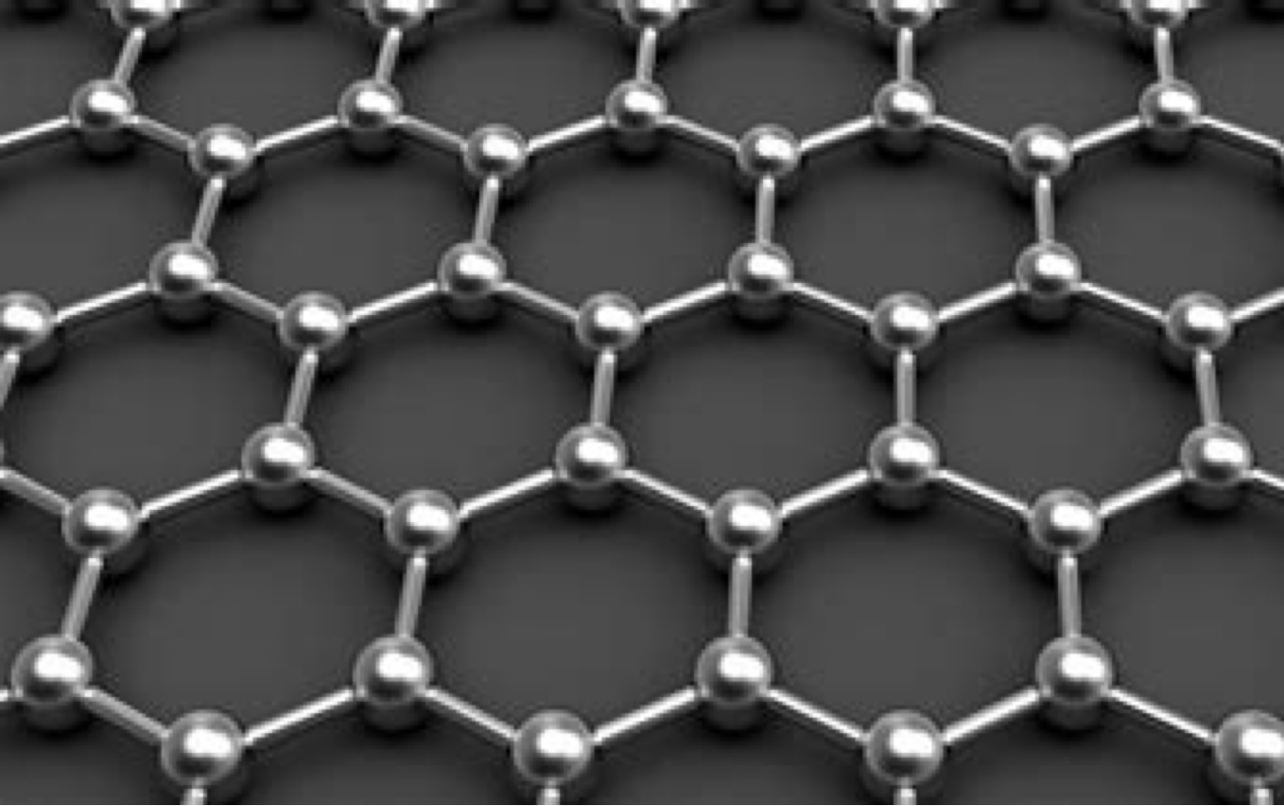
The plasma exhaust of a rotary magnetic engine, or so-called Plasma-Jet, looks deep electric blue to white. However, depending on the output frequency of the engine, which is variable, there can be a change in the color tone. This happens mostly when the spacecraft is inside the atmosphere of a planet. In space, the color change due to the different frequencies exists but it is very subtle, almost impossible to see.
Secondary Propulsion: Plasma jet, 7.5 TEVx4, plus 4 classified
It looks exactly the same. It is the same engine described above, same one as in the main propulsion: full immersion magnetic toroid, which is not propulsion, only as a "name", as it is only a different running mode of the same main counter-rotating turbine engines.
The only difference is that, in secondary propulsion, the counter rotating turbines don't close its energy flow, or 'flux', creating a toroid as in full immersion magnetic toroid mode. The electromagnetic plasma emitted by the high energy dynamics inside the engine(s) only rushes out of the exhaust nuzzle creating a plasma-jet effect, therefore producing thrust as a rocket engine would, but without the need of any kind of propellant or fuel.
Gravity manipulation engine pod
These are several polymorphic metal super alloy spheres placed one inside another, like an onion, each one rotating in the opposite direction to the one next to it and so on. Several layers depending on the size of the gravity engine.
As with the main engine turbines, there are no moving parts. The energy flux, or flow, is controlled by varying the resistance of the electric flow of the materials by changing the crystalline structure and therefore its superconductor properties, like its resistance to electric flow, creating the same spinning effect as if it had moving parts, but being much stronger and reliable.
Its general exterior looks are that of a smooth metal ball with some tubing and electrical superconductor cable and connections on its top and bottom, few on the sides, depending on the model.
Its diameter depends on the power output needed for each unit. And this depends on the size and use of the ship they will be installed in. A large ship usually has dozens of such units placed along its hull and they serve as control propulsion units for maneuvers, rarely used for propulsion only, as they are vastly inefficient as compared to a full-size electromagnetic plasma counter-rotating engine as the ones described above.
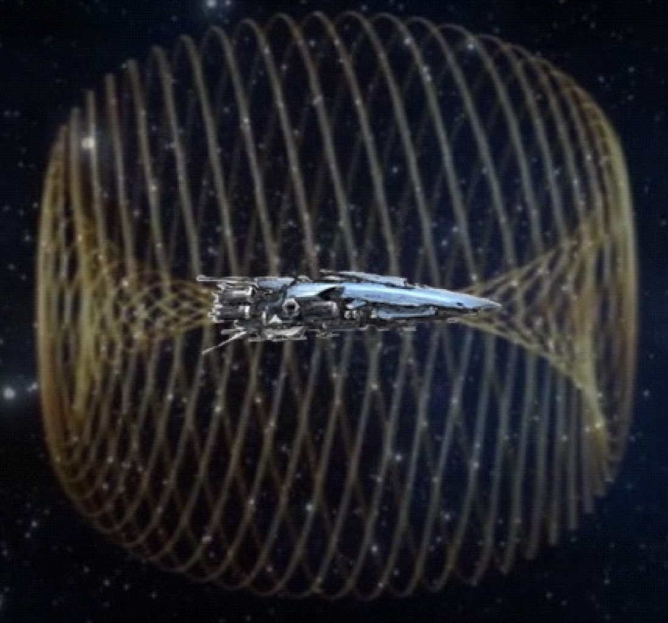
There is a new variant used on smaller ships such as fighter class starships like Suzy II, not found on Suzy I. Those are oval shaped high efficient magnetic anti-gravity generators that work with the same basic principle with the added efficiency of being able to generate the same amount of power output in a unit 50% to 60% smaller.
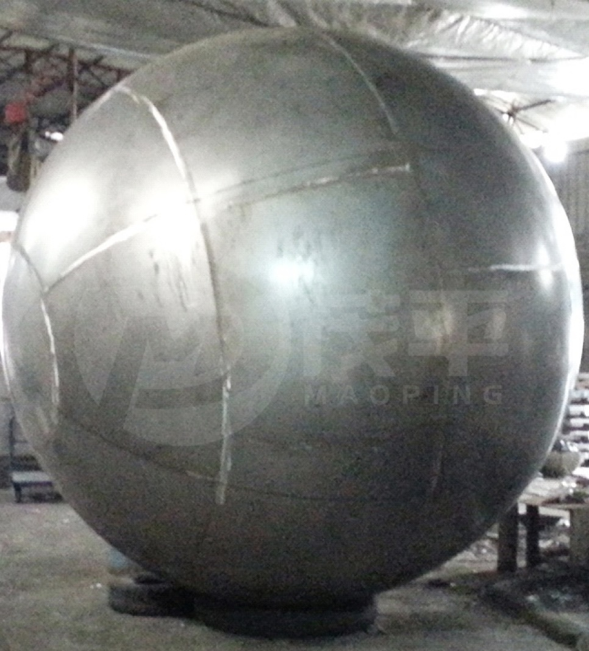
ORIGINALLY IN SPANISH
Robert: And why is a plasma jet better than a gravity canceller? Do they both use free energy in some way? Or how does it go?
Anéeka: Gravity cancelers, or gravity manipulators, have limited power, and are subject to interference from other gravity sources, such as suns, planets, or worse, black holes/wormholes. And they only partially remove the mass of the spacecraft relative to the plane or density in which it is located. They are susceptible to microwave interference, that's how they shot down Roswell's ships and the others.
Robert: Sure. It's not the same traveling above a planet with those ships as it is in space. And where do you get the plasma energy from?
Anéeka: The plasma-jet ones are very powerful, they wrap the ship entirely in a high-energy energetic toroid that jumps them out of density. Nothing interferes with their operation. They are invulnerable to countermeasures and microwaves or manipulated gravity.
The Zero Point reactor passes electricity to very large capacitors that increase it in volts and amperage to several Trillion TEV or Trillion Electron Volts, which are passed by superconducting systems to turbines that rotate in opposite directions, counter-rotating, where the electrical energy at super voltages is constantly changed in polarity inside the core of the turbine.
That is to say, with each spin several million times per second one turbine will be Positive + pole, and the other Negative-. This concentrates all the electrical energy in a single point, the turbine core, and is compressed to temperatures in excess of 3000°C. Electricity is turned on as controlled rays discharging between the poles of the counter-rotating turbines. The point is reached where the energy is so great that it becomes pure electric plasma and has only one way out: backwards. This creates a rocket or jet effect with a titanic thrust in metric tons.
And this plasma can be changed in frequency at will, controlled by computer. And with the frequency change, you wrap the whole ship putting the polarity ahead in the hull, so that the high-energy energetic toroid wraps the whole ship. And with the frequency change, you change density or direction in space-time using stellar frequency maps.
Robert: Thank you, yes. It is the image made by Swaruu. I understand.
Anéeka: Yes, I know you know it. But it is what I am describing here. Leaving gravitational cancellation and manipulation, in a modern ship, only as maneuvering engines. Like control surfaces, ailerons or rudder in a normal aircraft.
Robert: Thank you. Can't the anti-gravity ones do the density jump?
Anéeka: Yes, they can make jumps, but Taygeta's ship technology has improved a lot in the last 2000 years or so.
Robert: So both types of engines can make those density jumps. Both types of engines can open and close portals, right?
Anéeka: Yes. So can the disks. But they need to have that shape because they are small, low energy engines. And they are vulnerable to weapons that counteract them.
Robert: Do you mean that Earth's combat ships already have anti-gravity technology?
Anéeka: Some do, not entirely, but for example the Sukhoi-57 already have gravity cancellers. And the Sukhoi of the SU-27, SU-30, SU-35 family already incorporate it in their systems but not as advanced as the SU-57.
Interstellar Life 4 - utenomjordisk teknikk - reaktorer/plasmamotorer (Taygeta - Pleiader)
ORIGINAL PÅ ENGELSK - 2021

Gosia: Hvordan ser de ut, Zero Point-reaktorer?

Swaruu X (Athena): En nullpunktreaktor kan se annerledes ut avhengig av arten, kulturen, størrelsen og modellen til håndverket, men her vil jeg konsentrere meg om to typer som for det meste brukes i såkalt 'moderne tid' av Taygetan-kulturen som stort sett bare varierer i størrelse. Den ene, de større som brukes på store og tunge stjerneskip, og den mindre varianten som brukes til små smidige fartøyer som jagerfly.

Fra innsiden av et skip, vær i stor eller liten, når du først er i reaktorkontrollrommet, i de tekniske nivåene til fartøyet, er alt du kan se en flat metallfarge, glatt vegg med store rektangulære paneler uten håndtak. På noen skip er alt du kan se to vegger i 90° vinkler av samme glatte metallstålfarge med avtagbare paneler. Disse panelene kan alle fjernes til det punktet hvor hele veggen er borte.

I et Suzy klasse II jagerskip er kontrollrommet hvor du kan se denne veggen et hvitt firkantet lite rom uten rette vinkler i hjørnene, ikke større enn 8 kvadratmeter. Veggene er flate, men alle hjørnene er avrundet og de er alle rent hvite med hvitt tak og lys som kommer fra en stor ring på taket som nesten berører veggene i omkretsen.

Hovedinngangen er på veggen motsatt av reaktorveggen, og er en stor rektangulær skyvedør, avrundede kanter, og den øvre halvdelen av disse dørene er gjennomsiktige. Gulvet er mørkegrått og i midten er det to hvite rektangulære paneler med betjeningsflaten skråstilt i en liten vinkel. Når den er i av-posisjon, er kontrollflaten svart glass. Når den er på, manifesterer eller produserer den kontrollene, knappene og forlatene, som 3D-hologrammer over den overflaten etter behov. Kontrollskjermene er kun av den holografiske typen som vises foran brukeren, og presenterer alle dataene etter behov. Denne 3D-hologramskjermen kan modifiseres i størrelse og objektene der kan manipuleres for hånd eller ved tanke ved hjelp av hjerne til AI-grensesnitt etter ønske.

Selve reaktoren, sett ved fjerning av tilgangspanelene beskrevet ovenfor, eller sett før den installeres på et skip, som for eksempel når den står alene i et lager, er en stor metallkule. Størrelsen varierer avhengig av skipet det er ment for, og det som er synlig er en vev av nøye ordnede ovale rør som dekker hele overflaten og ordnet kommer ut fra hvert panel eller underseksjon av overflaten av kulen og beveger seg nedover mot gulvet , hver ender med kontakter og adaptere for å installere den på skipets reaktorrom. Blant disse rørene er det en annen mindre synlig bane av romtemperatur superlederkabler av liten kaliber.

Begge, selve kulen og dens ovale rør, er stålfarge, kablene er svarte med bronsefargede kontakter. Slangen er plassert rundt kulen på en slik ordnet måte at den vil minne deg om solid state-kretser. Når jeg sier oval rør, betyr det at hvis du kutter en av disse, vil tverrsnittet være en flat oval i form og ikke rund.

Veldig nært bilde. Men i stålfarge, ikke grønt.

Selv om jeg i denne delen kun skal beskrive hvordan en nullpunktsreaktor ser ut og ikke hvordan den fungerer, som det har blitt beskrevet i detalj før, vil jeg nevne noen ting her.

Banen av ovale rør som omslutter hele reaktorkulen er ikke kun til ett formål. Det er kanalrør, det vil si flere funksjoner, og underrør, ledninger og veier er inneholdt i dem for mange formål. Noen gir beskyttelse for superledende kabler som mater kunstig gravitasjonsmanipulasjon av elektromagnetiske frekvensgeneratorer som kontrollerer reaktorens kjerne. Andre er kablene som leder elektrisiteten som genereres av reaktorens kjerne til 'elektriske strømkollektorer', i mangel av et bedre ord. Andre tar elektrisitet fra de termoelektriske cellene på den indre overflaten av sfæren, også til 'kollektorene' tilsvarende kanskje kondensatorer.

Blant de termoelektriske cellene inne i den indre reaktorkuleveggen er det også en bane eller en rekke av rørsett som en sfærisk varmeradiator som dekker hele den indre overflaten. Denne radiatoren er fylt med kjølevæske og skal avkjøle reaktoren, for å holde den på ønsket indre temperatur. Denne varme væsken kjøles deretter av ved hjelp av hydrotermiske elektriske enheter som omdanner varme til mer elektrisitet.

Over denne spesielle radiatoren som et kjølesystem som rører gravitasjonsgeneratorene, er elektromagnetiske frekvensmodulatorer installert og mellom dem er det også termoelektriske paneler.

Kjernen i reaktoren, som beskrevet tidligere, er en kompleks 12-trinns toroidkule laget av hundretusenvis av små merkabah-formede syntetiske kvartsobjekter i sandkornstørrelse som flyter i et datastyrt gravitasjonsfelt som leder dem til å bevege seg i en 12-toroidal bane.
y. Dette er en toroid inne i en annen, inne i en annen, som hver danner den andre, i 12 nivåer. Men for øyet ser det i grunnen ut som en glødende semi-transparent kule som beveger seg på seg selv og flyter i midten av reaktorkulen.

Det beste bildet jeg har for å forklare dette er det følgende. Og vi har hatt det i årevis som et notat: (dette er GIF, men i en tekst er det statisk)

Dette er det nærmeste bildet vi kan komme for å beskrive hvordan innsiden av en nullpunktreaktor ser ut. Komplett med kjølevæskeradiatoren, kjøleenhetene og de kvadratiske termoelektriske kollektorene og gravitasjonsgeneratorene i bakgrunnen, og reaktorens toroidale kjernekule i forgrunnen.

Dette er også GIF:

Effekten fra en hvilken som helst nullpunktsreaktor basert på krystall Merkabah-toroider, som derfor gir plass til navnet Crystal Core Zero Point-reaktor, styres av de elektromagnetiske gravitasjonsgeneratorene som i sin tur styres av skipets AI. Og det oppnås ved å variere avstanden mellom og tettheten til de kunstige kvarts Merkabahs samt rotasjonshastigheten til hele toroid, eller også variere hastigheten og relative rotasjonshastigheten mellom hvert av de 12 nivåene som utgjør toroid.

I utgangspunktet er hovedprinsippet at når den toroidale kulen er større, har den mindre tetthet, derfor mindre gnistgap-virkning mellom kvarts Merkabah, og reduserer derfor den potensielle produksjonen. Og når den toroidale sfæren er mindre og beveger seg raskere i indre og ytre rotasjon, har den mer tetthet, og genererer derfor mer gnistgap-handling (i mangel på bedre ord), og med det mer elektrisitet og mer varme og lysstyrke.

Merkabah-formede syntetiske kvartskrystaller er laget med presis matematisk presisjon og presise størrelse og proporsjoner. De er laget av kjemisk ren krystall. Det er derfor de må være kunstig laget, og også ha nøyaktig konstruerte piezoelektriske egenskaper. Det matematiske grunnlaget kvartsen Merkabah følger er basert på nøyaktige 12 matematiske ligninger, som beskrevet i tidligere arbeid.

Ser ut som en liten nullpunktreaktor. Bilde: liten fusjonsreaktor.

Som nevnt ovenfor avhenger størrelsen på en nullpunktsreaktor av hva den skal brukes til. I en stor cruiser, som Toleka-klassen, er de nesten 10 meter i diameter, og et skip med den massen har fire av dem for å mate sine store motorer og systemer. I et mindre fartøy, som en Suzy klasse II, er de mye mindre, siden reaktorkulen i seg selv bare er 3 til 3,5 meter i diameter (ikke medregnet rør og ekstra maskineri).

Men jeg vet at det er bygget mye større Crystal Core Zero Point-reaktorer. Og på den andre siden av spekteret er det Zero Point-reaktorer som fungerer med samme prinsipp som kan passe inn i håndflaten din. De brukes til å drive små droner, elektronisk utstyr med lang rekkevidde for romfart, og til å drive våpen som avanserte ACR plasmarifler og mindre ACP-er, begge i stand til høy skuddhastighet eller restitusjonstid og uten behov for å lade på nytt, da de aldri gå tom for ammunisjon, blant mange andre bruksområder.

(Som en sidenotat, på steder som Temmer eller Erra, inne i et planetarisk trådløst strømnett, er det ikke nødvendig med slike små reaktorer for å drive hverdagslige enheter, da de alle henter energien fra trådløs elektrisitetsoverføringsteknologi, lik Teslas på jorden, før de ble skjult for offentligheten av Thomas Edison, siden det ville være umulig å plassere en måler og derfor fakturere kundene deres).

Om formen og fargen på indre merkaba-kvartskrystaller som utgjør kjernen i reaktoren, er de omtrent på størrelse med et korn av fin sand eller salt.

Den eneste forskjellen er at det, på bildet, er tresidige Merkabah-objekter, og de i Zero Point-reaktorer er firesidige Merkabah-objekter, som i form av to pyramider plassert inne i den andre, den ene opp ned i motsetning til den første.

Plasma turbinmotorer

Det finnes flere varianter av plasmadrevne turbinmotorer. Jeg bruker navnet "turbin" fordi den spinner inni, så det er en turbin. I motsetning til en jetmotor har den ingen kompressor, kompressortrinn, brennere eller etterbrennere. Den krever ingen form for drivstoff eller drivstoff. Den fungerer ved å spinne komponentene i motsatte retninger mens den mates med billioner av elektronvolt, og dette skaper et veldig stort elektromagnetisk plasmafelt.

Størrelsen på motoren varierer avhengig av skipet, men alle fungerer med samme prinsipp. Det er en sylinder eller et stort rør, hult innvendig, med en kjegle bak. Sylinderens vegger er selve turbinen, og den er laget av flere lags sylindre inne i hverandre. Mengden av disse sylindrene avhenger av skipets modell, men de fleste store og noen jagerflyklasser har 12 lag, som hver roterer i motsatt retning.

Selv om en elektromagnetisk plasmamotor på utsiden kan se veldig lik ut som en jetmotor, er den innvendig veldig forskjellig, men det generelle utseendet er veldig likt.
Jeg
n prinsippet roterer hvert lag i motsatt retning av det tidligere, med klokken, det andre mot klokken. Hver av dem mates med en annen høyspent elektrisk polaritet, og de roterer alle over samme senter eller geometriske aksel. Dette skaper et sterkt elektromagnetisk felt, som sagt før. Dette feltet har en frekvens, og denne frekvensen styres av skipets AI-datamaskin. Kontroll av denne frekvensen oppnås ved å variere rotasjonshastigheten, spenningen og forholdet mellom rotasjonsmønstrene mellom lagene i den motroterende turbinen.

I eldre skip var turbinene laget av et sett med sylindre, den ene inne i den andre, som russiske Matryoshka-dukker. Og kraften til hvert nivå, eller til hver enkelt roterende trommel, oppnås ved hjelp av en kraftfordeler i frontenden av turbinen, motsatt av eksosmunnstykket.

I nyere skip oppnås dette ved å endre molekylstrukturen til hvert lag i bølger. Den ene med klokken, den andre mot klokken.

Hvert sylindernivå som utgjør turbinen vil endre sin molekylære struktur som forårsaker en krusning som går rundt hver sylinder.

Det er viktig å forstå at materialet som brukes i denne typen toppmoderne turbiner er polymorf krystallinsk metall superlegering. Dette betyr at selve dens molekylære struktur endres i henhold til hva datamaskinen dikterer dem. Så hvis du har en tilsynelatende solid turbintrommel, og du endrer den molekylære krystallinske strukturen som utgjør den på en progressiv måte, som i en bølge, skaper du en illusjon av å spinne i dens molekylære matrise.

Polymorft metall

Som sett her, er de små kulene metallets molekylære struktur, og det er strukturen, selve molekylene som endres under IA-kontroll for å skape en illusjon av spinning.

En krystallinsk molekylstruktur i et stoff eller materiale er når molekylene er satt med en presis geometrisk form og rekkefølge. Dette er det grunnleggende prinsippet bak transparente materialer. Siden strukturen deres er i orden, lar den lys passere gjennom med liten motstand, og blir derfor gjennomskinnelig.

Samme effekt gjelder for superledermaterialer der elektrisitet kan strømme gjennom molekylene i materialet uten å møte motstand.

Når elektrisitet passerer gjennom et ikke-superledermateriale, som for eksempel kobbertråd, flyter det på en kaotisk måte, hvert elektron i den elektriske strømmen banker og kjemper seg gjennom metallets kaotiske struktur.

Perfekt krystallinsk metallisk molekylær matrise, lik den som finnes i superledere:

Så, tilbake til toppmoderne elektromagnetiske plasmaturbiner som brukes til stjerneskip. Hvert trommellag vil ha sin krystallinske strukturendring på grunn av dets polymorfe metallegenskaper som kontrollert av skipets AI ved å bruke tyngdekraft og frekvensstyring for å målrette spesifikke områder i turbinens struktur for å endres. Polymorfe metalls molekyler reagerer på frekvens og tyngdekraft og tvinger dem til å endre forholdet til hverandre (mer om det). Denne endringen kan sees i en molekylær spak som en krusning som beveger seg rundt trommelen.

På hvert nivå av trommene som er én inne i hverandre, vil "bølgen" bevege seg i en eller annen retning, og forårsake en spinnende effekt selv om det ikke er noen bevegelige deler. Dette er den viktigste forskjellen mellom gammel stjerneskipteknologi og toppmoderne som brukt på en Suzy II-klasse. Ingen bevegelige deler, og alt utført med polymorfe metallegenskaper. Plasmaturbiner i eldre skip roterte som en komplett turbin, og i motrotasjon i henhold til nivåene.

Det faktum at det ikke er noen bevegelige deler, men fortsatt er den molekylære effekten av en turbin, gjør at denne motortypen er langt mer pålitelig enn den roterende typen, og tillater også at frekvensutgangen er langt mer presis.

Når turbinen spinner molekylært, endrer AI sammensetningen eller "formen" av den krystallinske strukturen til turbinen, endret i tetthet og form. Med dette møter den elektriske høyspenningsstrømmen som strømmer gjennom den på en superledende måte mer eller mindre motstand, og dette fører til at dens elektromagnetiske frekvens også endres, og derfor endrer frekvensforholdet med andre lag i hele turbinmotoren. Og summen av alle interaksjonene mellom lagene i motorens indre turbiner vil resultere i den totale eller rå frekvenseffekten til hele motoren.

Ved å endre det indre frekvensforholdet mellom komponentene, vil plasmastrømmen ut av motordysen ha en bestemt frekvens. Denne spesifikke frekvensen er av svært høy energi karakter på grunn av mengden rå elektrisk kraft som mates inn i motoren i størrelsesorden flere billioner elektriske volt eller TEV (ikke gir bort spesifikke effektavlesninger).

Som forklart i andre verk, beveger et stjerneskip seg ikke, når det navigerer raskere enn lyset, så det er ikke fremdrift. Et skip vil endre sine spesifikasjoner

c-frekvensen for å matche den til destinasjonen, derfor "hopper" der. Dette betyr at romkart må lages kun ved bruk av frekvens. Dette er å lese den spesifikke frekvensen til hvert 'sted' i et rutenett i rommet og huske det i AI-datamaskinen.

Så, i prinsippet, når et skip må reise fra sted 'A' til punkt 'B', er alt det trenger å gjøre å endre hele frekvensen, vibrasjonsfrekvensen, som i tetthet og dimensjoner, for hele skipet, så det vil ikke lenger være "kompatibelt" med sted "A" og vil være til ønsket destinasjon, sted eller sted "B".

Dette illustrerer hvorfor styringen av nøyaktige frekvensutganger til motorene er så viktig. Også fordi motoren må emulere eller tilpasses presise mikrofrekvensjusteringer for å kompensere for andre ukjente faktorer som kan forstyrre hele frekvensutgangen og forårsake et sannsynlig avvik fra bestemmelsesstedet, eller ganske enkelt for å mikrojustere hvor og når et skip vil ankomme til bestemmelsesstedet, eller punkt 'B', i eksemplet ovenfor. Fordi, ettersom en plassering er en spesifikk frekvens i et kart, er det også tid, og det nøyaktige øyeblikket et skip skal ankomme for å sette destinasjon 'B'. Alt dette kontrollert med styring av motorens frekvensutgangssystem.

Ettersom steder og steder er frekvenser innenfor et kart eller rutenett, alle representert av numeriske faktorer, er det også tid. Øyeblikket i tid, fortid, nåtid eller fremtid for et sted, styres også ved bruk av kontrollerte frekvenser som allerede er kjent for å være representative for ønsket sted og tidspunkt. Punkt i rom-tid.

Å endre hele skipets eksistensfrekvens, eller vibrasjon, for å matche den av dets ønskede destinasjon, oppnås ved å bruke en full nedsenkings-toroideffekt forårsaket av det høyenergiske elektromagnetiske feltet som motoren eller motorene produserer. At kjernen i motoren er kjernen, eller såkalt "motor" også, av hele toroid, der en polaritet er bak som en elektromagnetisk plasmautgang, og den andre polariteten finnes ved nesen av romskipet , som er at toroiden er koblet til turbinen og toroidmotorene ved hjelp av skroget og strukturen til selve fartøyet, hovedsakelig hjulpet av massive superledende kabler som går fra den spesielle nesen til fartøyet som fungerer som en mottaker til baksiden av motorene hvor den elektromagnetiske energien legges til den nye motoren(e) produserer.

Plasmaeksosen til en roterende magnetisk motor, eller såkalt Plasma-Jet, ser dypt elektrisk blått til hvitt ut. Avhengig av utgangsfrekvensen til motoren, som er variabel, kan det imidlertid være en endring i fargetonen. Dette skjer mest når romfartøyet er inne i atmosfæren til en planet. I verdensrommet eksisterer fargeendringen på grunn av de forskjellige frekvensene, men den er veldig subtil, nesten umulig å se.

Sekundær fremdrift: Plasmajet, 7,5 TEVx4, pluss 4 klassifisert

Det ser akkurat likt ut. Det er den samme motoren beskrevet ovenfor, den samme som i hovedfremdriften: magnetisk toroid med full nedsenking, som ikke er fremdrift, bare som et "navn", siden det bare er en annen driftsmodus for de samme hovedmotorene med motroterende turbiner. .

Den eneste forskjellen er at ved sekundær fremdrift stenger ikke de motroterende turbinene sin energiflyt, eller "fluks", og skaper en toroid som i full nedsenkingsmagnetisk toroidmodus. Det elektromagnetiske plasmaet som sendes ut av den høye energidynamikken inne i motoren(e) suser bare ut av eksosmunnstykket og skaper en plasmajeteffekt, og produserer derfor skyvekraft som en rakettmotor ville gjort, men uten behov for noen form for drivstoff eller drivstoff.

Gravity manipulation motor pod

Dette er flere polymorfe metall-superlegeringskuler plassert i hverandre, som en løk, som hver roterer i motsatt retning av den ved siden av og så videre. Flere lag avhengig av størrelsen på gravitasjonsmotoren.

Som med hovedmotorens turbiner er det ingen bevegelige deler. Energifluksen, eller strømmen, kontrolleres ved å variere motstanden til den elektriske strømmen av materialene ved å endre den krystallinske strukturen og derfor dens superlederegenskaper, som motstanden mot elektrisk strømning, og skaper den samme spinneeffekten som om den hadde bevegelige deler, men er mye sterkere og pålitelig.

Dens generelle ytre utseende er som en glatt metallkule med litt rør og elektrisk superlederkabel og tilkoblinger på toppen og bunnen, noen få på sidene, avhengig av modell.

Diameteren avhenger av kraftuttaket som trengs for hver enhet. Og dette avhenger av størrelsen og bruken av skipet de skal installeres i. Et stort skip har vanligvis dusinvis av slike enheter plassert langs skroget, og de fungerer som kontrollfremdriftsenheter for manøvrer, som sjelden kun brukes til fremdrift, da de er i stor grad. ineffektiv sammenlignet med en full-størrelse elektromagnetisk plasma motroterende motor som de som er beskrevet ovenfor.

Det er en ny variant som brukes på mindre skip, for eksempel stjerneskip i jagerklasse som Suzy II, som ikke finnes på Suzy
I. Dette er ovale høyeffektive magnetiske anti-tyngdekraftsgeneratorer som fungerer med det samme grunnleggende prinsippet med den ekstra effektiviteten å kunne generere samme mengde utgangseffekt i en enhet som er 50 % til 60 % mindre.

ORIGINAL PÅ SPANSK

Robert: Og hvorfor er en plasmajet bedre enn en gravitasjonskanseller? Bruker de begge gratis energi på en eller annen måte? Eller hvordan går det?

Anéeka: Tyngdekraftsdempere, eller gravitasjonsmanipulatorer, har begrenset kraft, og er utsatt for forstyrrelser fra andre gravitasjonskilder, som soler, planeter, eller enda verre, sorte hull/ormehull. Og de fjerner bare delvis romfartøyets masse i forhold til flyet eller tettheten det befinner seg i. De er mottakelige for mikrobølgeinterferens, det var slik de skjøt ned Roswells skip og de andre.

Robert: Klart det. Det er ikke det samme å reise over en planet med disse skipene som det er i verdensrommet. Og hvor får du plasmaenergien fra?

Anéeka: Plasma-jet-ene er veldig kraftige, de pakker skipet helt inn i en energisk toroid med høy energi som hopper dem ut av tetthet. Ingenting forstyrrer driften deres. De er usårbare for mottiltak og mikrobølger eller manipulert gravitasjon.

Nullpunktreaktoren sender elektrisitet til svært store kondensatorer som øker den i volt og strømstyrke til flere billioner TEV eller trillioner elektronvolt, som ledes av superledende systemer til turbiner som roterer i motsatte retninger, motroterende, hvor den elektriske energien ved super spenninger endres konstant i polaritet inne i kjernen av turbinen.

Det vil si at med hvert spinn flere millioner ganger per sekund vil en turbin være positiv + pol, og den andre negativ-. Denne konsentrerer all elektrisk energi i ett enkelt punkt, turbinkjernen, og komprimeres til temperaturer over 3000°C. Elektrisitet slås på som kontrollerte stråler som slipper ut mellom polene til de motroterende turbinene. Punktet er nådd hvor energien er så stor at den blir ren elektrisk plasma og har bare én utvei: bakover. Dette skaper en rakett- eller jeteffekt med en titanisk skyvekraft i metriske tonn.

Og dette plasmaet kan endres i frekvens etter ønske, kontrollert av datamaskinen. Og med frekvensendringen pakker du inn hele skipet og legger polariteten foran i skroget, slik at den energirike toroiden omslutter hele skipet. Og med frekvensendringen endrer du tetthet eller retning i rom-tid ved å bruke stjernefrekvenskart.

Robert: Takk, ja. Det er bildet laget av Swaruu. Jeg forstår.

Anéeka: Ja, jeg vet at du vet det. Men det er det jeg beskriver her. Etterlater gravitasjonskansellering og manipulasjon, i et moderne skip, bare som manøvreringsmotorer. Som kontrolloverflater, rulleroer eller ror i et vanlig fly.

Robert: Takk. Kan ikke anti-tyngdekraften gjøre tetthetshoppet?

Anéeka: Ja, de kan gjøre hopp, men Taygetas skipsteknologi har forbedret seg mye de siste 2000 årene eller så.

Robert: Så begge typer motorer kan gjøre de tetthetshoppene. Begge typer motorer kan åpne og lukke portaler, ikke sant?

Anéeka: Ja. Det kan diskene også. Men de må ha den formen fordi de er små, lavenergimotorer. Og de er sårbare for våpen som motvirker dem.

Robert: Mener du at jordas kampskip allerede har anti-tyngdekraftsteknologi?

Anéeka: Noen gjør det, ikke helt, men for eksempel Sukhoi-57 har allerede gravitasjonskansellerere. Og Sukhoi fra SU-27, SU-30, SU-35-familien har allerede innlemmet det i systemene sine, men ikke så avansert som SU-57.

